TRACING THE GROWTH OF GLOBLE COMMUNITY; POPULATION FORECASTING ANALYSIS

1. Introduction

1.1Overview

The world’s population is more than three times larger than it was in the mid-twentieth century. The global human population reached 8.0 billion in midNovember 2022 from an estimated 2.5 billion people in 1950, adding 1 billion people since 2010 and 2 billion since 1998. The world’s population is expected to increase by nearly 2 billion persons in the next 30 years, from the current 8 billion to 9.7 billion in 2050 and could peak at nearly 10.4 billion in the mid-2080s. This dramatic growth has been driven largely by increasing numbers of people surviving to reproductive age, the gradual increase in human lifespan, increasing urbanization, and accelerating migration. Major changes in fertility rate have accompanied this growth. These trends will have far-reaching implications for generations to come.

1.2Purpose

The world's population is expected to increase by nearly 2 billion persons in the next 30 years, from the current 8 billion to 9.7 billion in 2050 and could peak at nearly 10.4 billion in the mid-2080s.

2. Problem definition and design thinking

2.1Empathy map

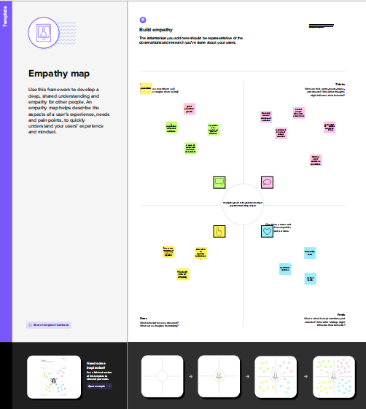

3. Result

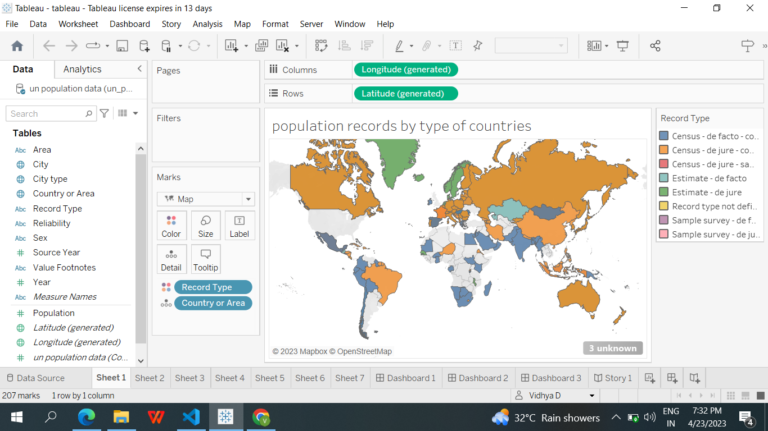

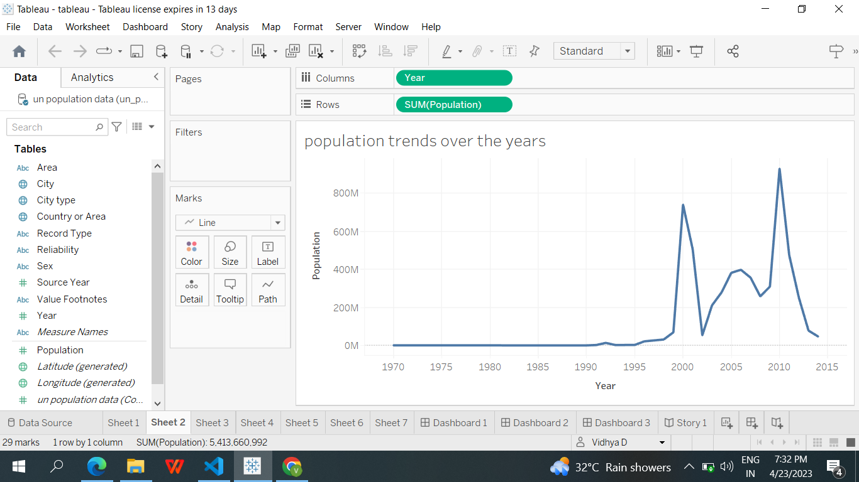

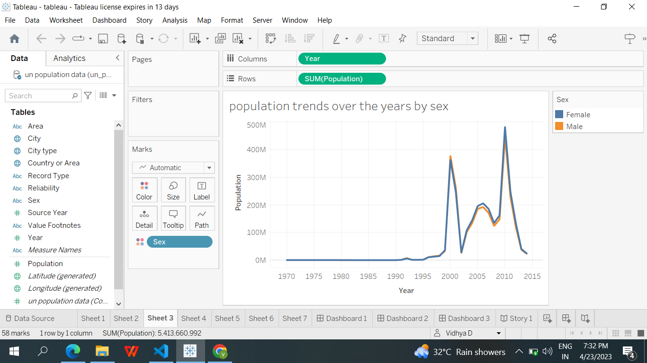

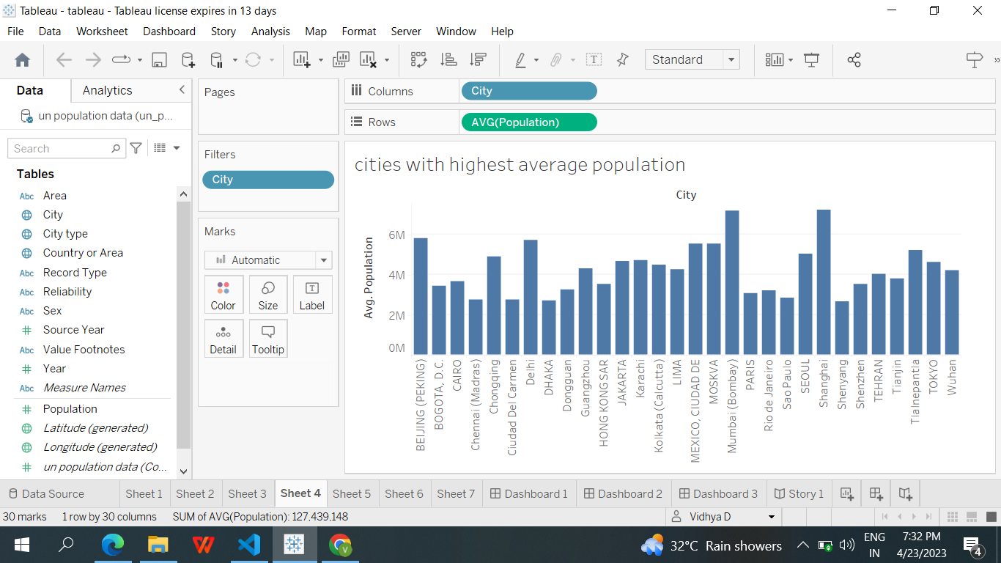

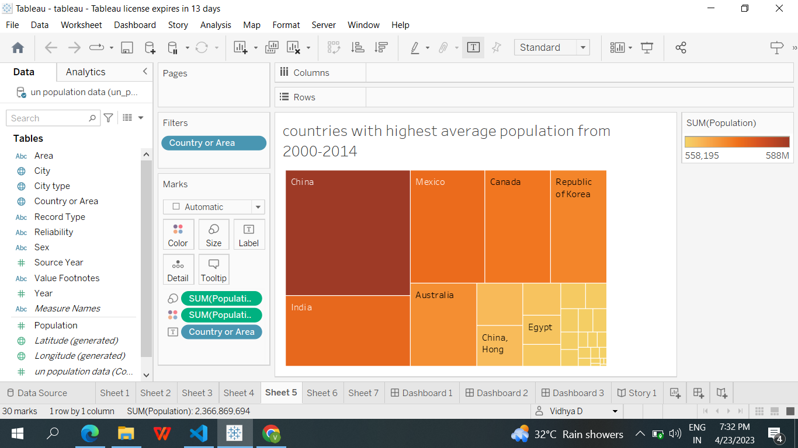

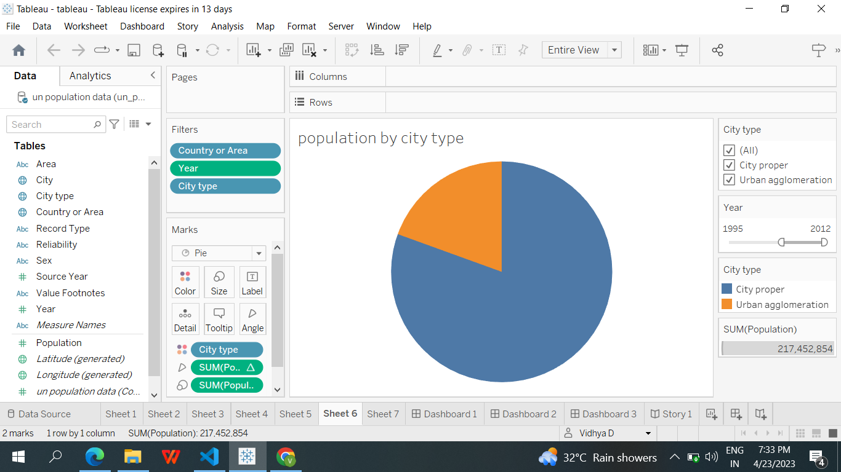

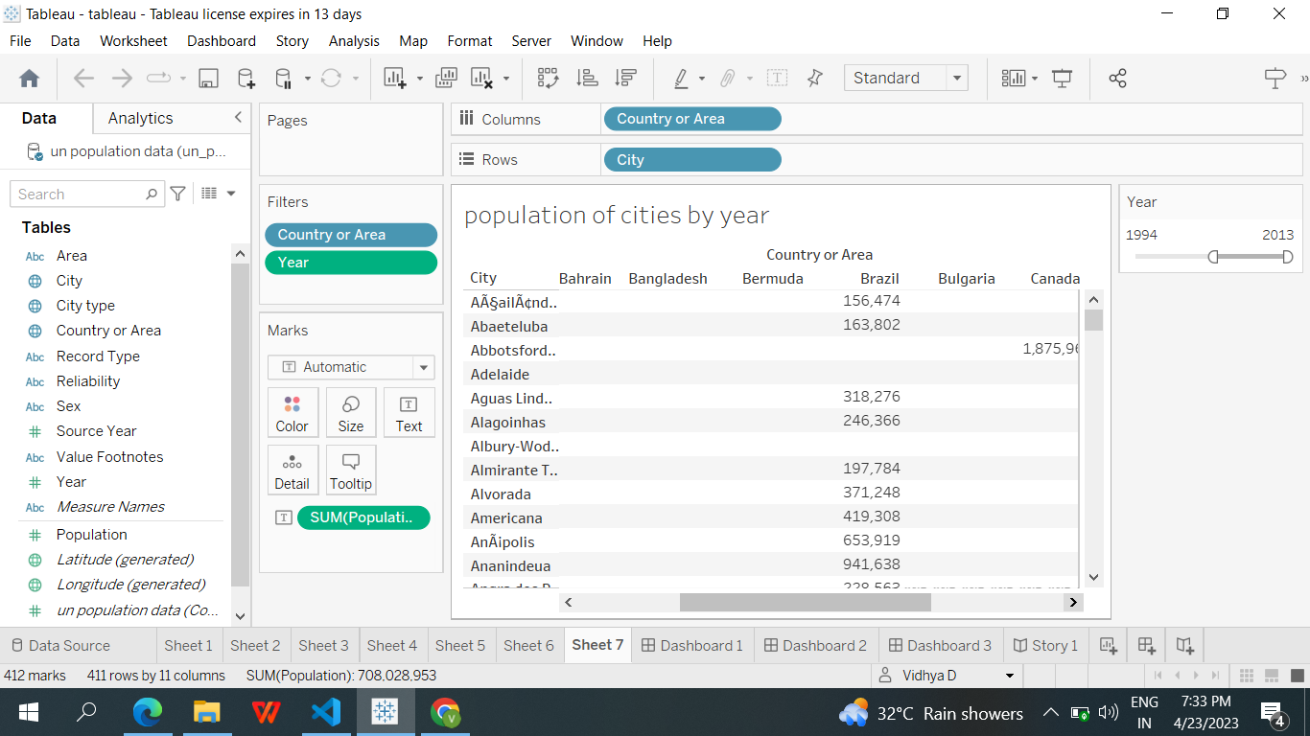

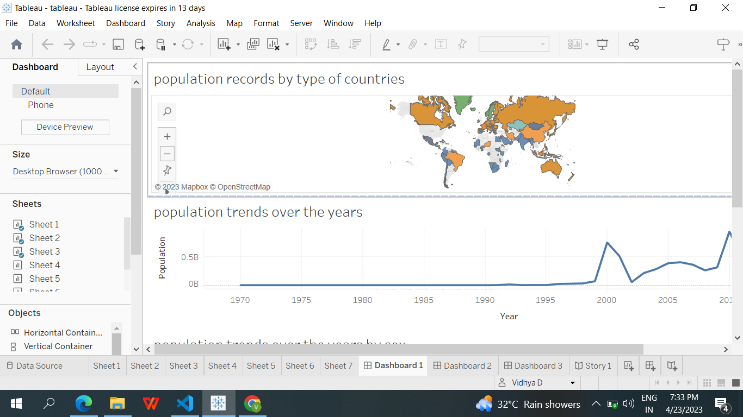

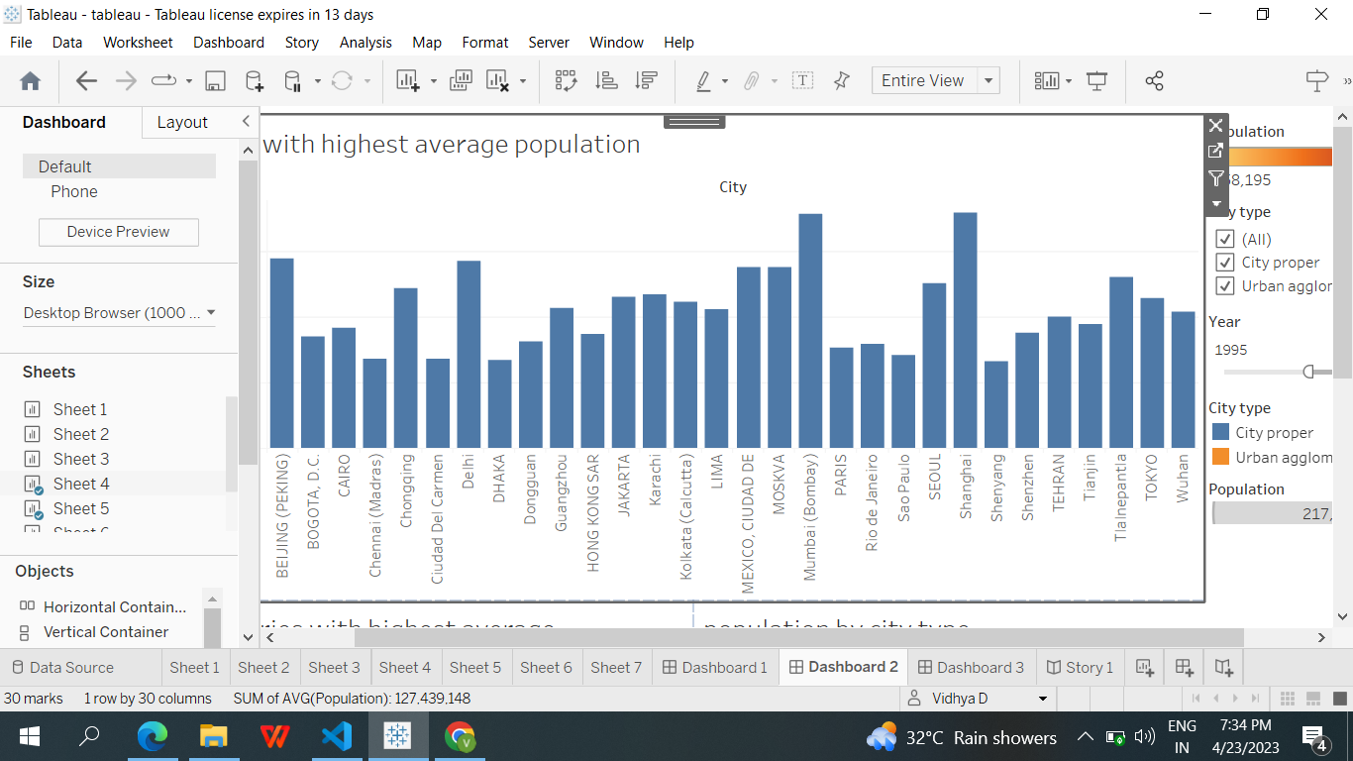

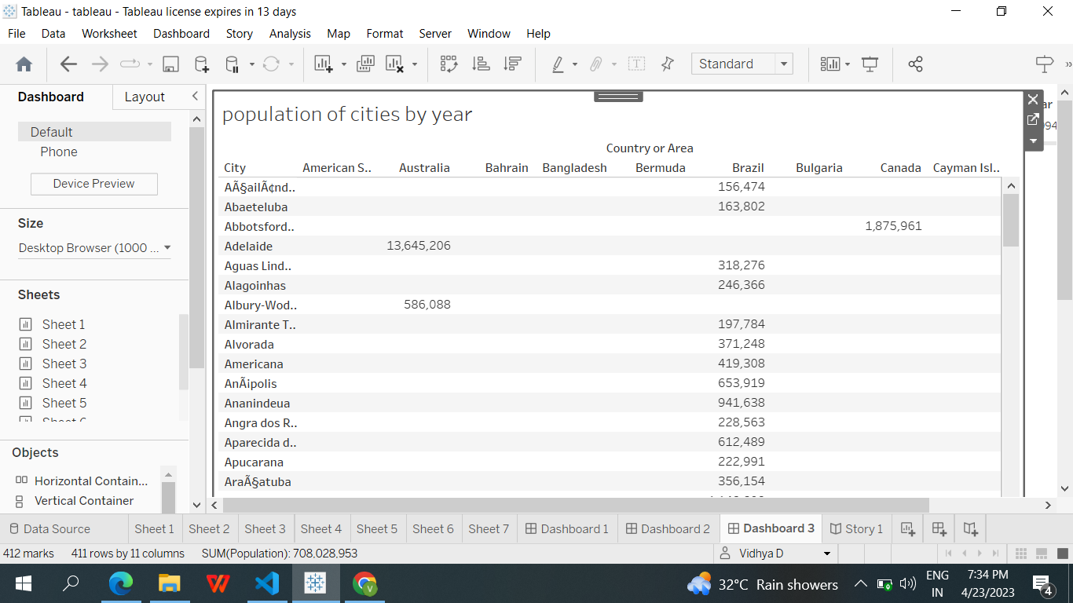

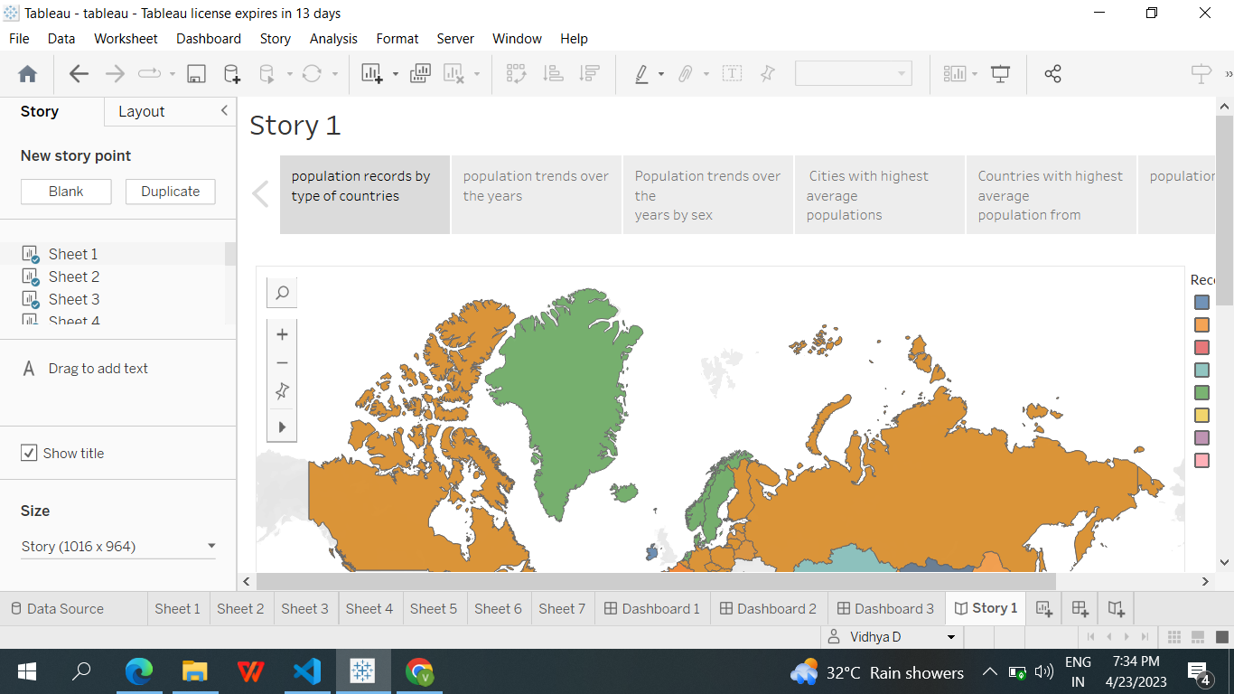

Advantages and Disadvantage

Advantages

❖ More people leads to greater

❖ Higher economic growth

❖ Economies of scale

❖ The efficiency of higher population density

❖ the improved demographic structure of society Disadvantages

❖ Cost to the environment

❖ Congestion

❖ Water shortages

❖ Problem of Unemployment

Application

The main purpose of producing population projections is to provide an estimate of the future population as a common framework for use in planning, policy formation and decision making in a number of different fields.

Conclustion

The Earth's current population is almost 7.6 billion people, and it is expanding. It is expected to surpass 8 billion people by 2025, 9 billion by 2040, and 11 billion by 2100. The population is quickly increasing, far surpassing our planet's ability to maintain it, given existing habits.

Future scope

• Gender equality and women’s empowerment As changing economic and social conditions diminish the desire for large families, the fertility level in a population tends to fall. The reduction in fertility desires contributes to changing expectations around motherhood and women’s roles in society, and thus provides an opening for women to pursue higher levels of education and greater economic participation. At the same time, advances in gender equality and women’s empowerment contribute to the decline of fertility through the delay of marriage and childbearing and through an improved realization of fertility intentions.

• Poverty and inequality High levels of fertility, rapid population growth and widespread poverty often go hand in hand, trapping countries, communities and individuals in a vicious cycle. In such cases, accelerating the transition from high to low levels of fertility, together with appropriate social and economic policies, can lead to sustained economic growth and poverty reduction.

Ideation and brainstorming

